**Task 2: GridView Binding to Collection of Objects**

1. Create a new window store app and choose a Blank App template. Call it name “**GridView Collection of Object**” or whatever you want.
2. Add a GridView Control from the toolbox in the MainPage.Xml. You can do it either by writing the XAML code, follow the below links for help
   1. <https://msdn.microsoft.com/en-us/library/windows/apps/xaml/hh780650.aspx>
   2. <https://msdn.microsoft.com/en-us/library/windows/apps/xaml/hh780627.aspx>

**Set a GroupStyle to specify how groups are displayed in GridView**

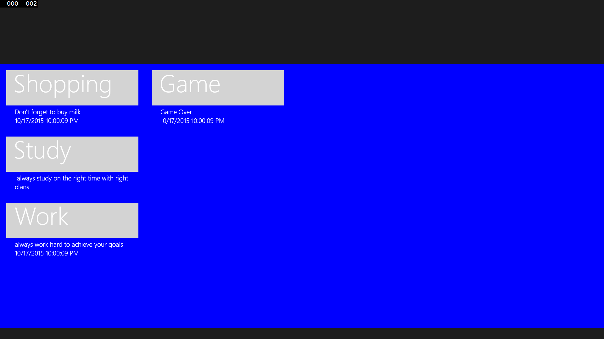

1. Make a new **NoteModel Class**. In this Class, define the **NoteText, Subject** & **DateTime** property. Let the model Class support notifications. Implement the **INotificationChanged** interface - including the handler and the OnPropertyChanged-method. For **NoteText**, **Subject** & **DateTime** property, call the notification in the set-method.

Follow the below links for better understanding:

<https://msdn.microsoft.com/en-us/library/edzehd2t(v=vs.110).aspx>

<https://msdn.microsoft.com/en-us/library/windows/apps/xaml/windows.ui.xaml.data.inotifypropertychanged.aspx>

<https://msdn.microsoft.com/en-us/library/windows/apps/xaml/windows.ui.xaml.data.inotifypropertychanged.propertychanged.aspx>.

1. Make a new **ViewModel Class**. In this Class, define the **Name** property. Let the model Class support notifications. Implement the **INotificationChanged** interface - including the handler and the OnPropertyChanged-method.
   1. Make a simple property **Notes** e.g. an ObservebleCollection<Note> Notes (also in set method call OnPropertyChanged).
   2. Make a constructor with some initial values for the Note collection.

For example (Notes.Add(new Note("Shopping", "Don't forget to buy milk"));

**5** Finally Set the **DataContext** on the MainPage.Xaml.cs File